**MetroGnome  
Project Plan**

Miles Anderson, Dax Lynch, Harry Robertson, Ryan Helms 5-12-24

**System Requirements****1**

1.1 System Overview 1

1.2 Justification for a New System 1

1.3 Operational Features of the Proposed System 2

1.4 User Classes and Modes of Operation 2

1.5 Operational Scenarios or Use Cases 2

1.6 Real-World Users

**System Design**

2.1 System Overview 2

2.2 Software Architecture 3

2.3 Software Modules

**Project Plan**

3.1 Overview

**Acknowledgements**

**Revision History**

|  |  |  |
| --- | --- | --- |
| **Date** | **Author** | **Description** |
| 5/12/24 | All | Initial document creation |
| 5/14/24 | MA / RH | Updated project plan and SRS, post interviews with musicians |
| 5/19/24 | All | Updated SDS and SRS, created models for various systems |

**3. Project Plan**

\

**3.1 Overview**

Our project plan consists of three main components, with those components leading into prototypes. Those prototypes, then, will be iterated upon until a final product is ready for delivery. We are using the iterative development approach, allowing for agile development and adjustments depending on the state and needs of our system and stakeholders. We also intend to leave ample time at the end to iterate upon our design and perhaps add additional functionality. Currently, we are waiting for input from music students. The three phases are as follows:

**3.2 Guitar Tuner**

At the crux of the application is the tuner. It will be built in parallel with the metronome (see section 3.2). As the technologies behind it are relatively simple, it will be built first.

**3.3 Metronome Module**

The second functionality of the web-app will be the metronome. We will develop the metronome in parallel with the guitar tuner, integrating both with the landing-page/front-end

**3.4 MetroGnome Landing Page**

The landing page will be the front-end hub in which users can launch both the metronome and the tuner. The tuner and metronome will be developed first, as the landing page is simply a means to access said components.

**3.5 MetroGnome Server**

JavaScript server built to handle user input and interaction. Will be hosted on a local machine or ix. Built following the landing page. Prior, we will be running on a local machine to limit coupling during development.

**3.6 Additional Functionality**

Time is left within the project plan to iterate upon the initial plan. Our software is intentionally modular to allow for such augmentations.

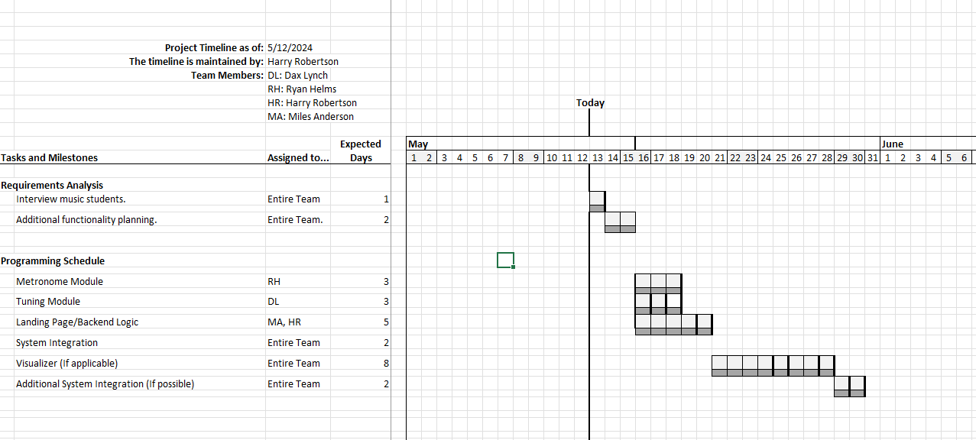

**Fig 3.5.1 (Optimistic) Gantt Chart of Project Timeline**

**4. Acknowledgements**